Experiment No. 4

- Write a program to create and display a list.

my_list = []
n = int(input("How many elements? "))
for i in range(n):
element = input(f"Enter element {i+1}: ")
my_list.append(element)
print(f"\nCreated List: {my_list}")
print(f"Total elements: {len(my_list)}")

Output:
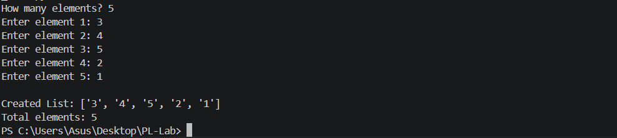
- Write a program to find sum and average of list elements.

n = int(input("How many numbers? "))
numbers = []
for i in range(n):
num = float(input(f"Enter number {i+1}: "))
numbers.append(num)
total = sum(numbers)
average = total / len(numbers)
print(f"\nList : {numbers}")
print(f"Sum : {total}")
print(f"Average : {average:.2f}")
Ouput:
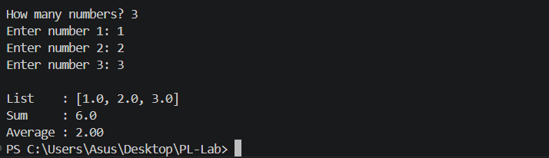
3.Write a program to find maximum and minimum element in a list.
n = int(input("How many numbers? "))
numbers = []
for i in range(n):
num = float(input(f"Enter number {i+1}: "))
numbers.append(num)
print(f"\nList : {numbers}")
print(f"Maximum : {max(numbers)}")
print(f"Minimum : {min(numbers)}")
Output:
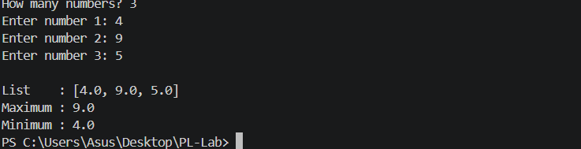
4.Write a program to sort elements of a list.
n = int(input("How many numbers? "))
numbers = []
for i in range(n):
num = int(input(f"Enter number {i+1}: "))
numbers.append(num)
print(f"\nOriginal list : {numbers}")
print(f"Ascending order : {sorted(numbers)}")
print(f"Descending order : {sorted(numbers, reverse=True)}")
Output:

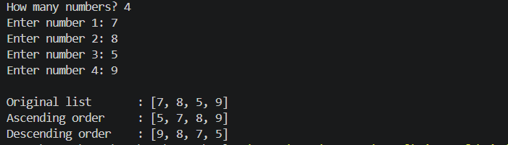

5.Write a program to remove duplicate elements from a list.
n = int(input("How many elements? "))
my_list = []
for i in range(n):
num = int(input(f"Enter element {i+1}: "))
my_list.append(num)
unique_list = list(dict.fromkeys(my_list)) # preserves order
print(f"\nOriginal list : {my_list}")
print(f"List after removing duplicates: {unique_list}")
Output:
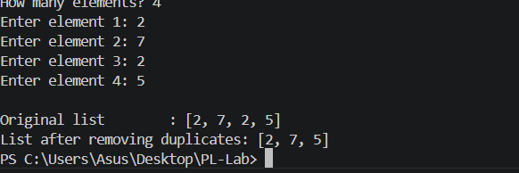
6.Write a program to search an element in a list.
n = int(input("How many elements? "))
my_list = []
for i in range(n):
num = int(input(f"Enter element {i+1}: "))
my_list.append(num)
search = int(input("Enter element to search: "))
print(f"\nList: {my_list}")
if search in my_list:
index = my_list.index(search)
print(f"Element {search} found at index {index}.")
else:
print(f"Element {search} NOT found in the list.")
Output:
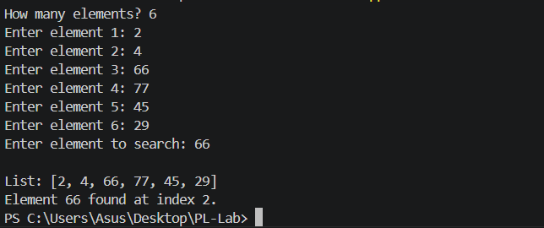
7.Write a program to merge two lists.
n1 = int(input("How many elements in List 1? "))
list1 = [int(input(f" List1 element {i+1}: ")) for i in range(n1)]
n2 = int(input("How many elements in List 2? "))
list2 = [int(input(f" List2 element {i+1}: ")) for i in range(n2)]

merged = list1 + list2
print(f"\nList 1 : {list1}")
print(f"List 2 : {list2}")
print(f"Merged : {merged}")
print(f"Sorted merged: {sorted(merged)}")
Output:
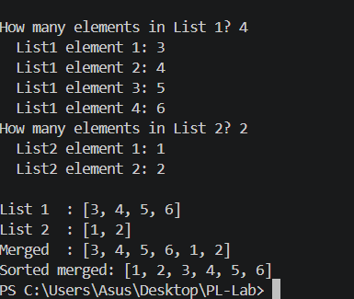
8.Write a program to count even and odd numbers in a list.
n = int(input("How many numbers? "))
numbers = [int(input(f"Enter number {i+1}: ")) for i in range(n)]
even = [x for x in numbers if x % 2 == 0]
odd = [x for x in numbers if x % 2 != 0]
print(f"\nList : {numbers}")
print(f"Even numbers : {even} (Count: {len(even)})")
print(f"Odd numbers : {odd} (Count: {len(odd)})")
Output:
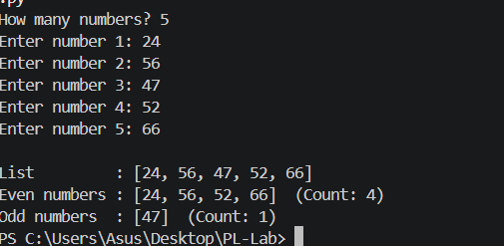
9.Write a program to find second largest element in a list.
n = int(input("How many numbers? "))
numbers = [int(input(f"Enter number {i+1}: ")) for i in range(n)]
unique_numbers = list(set(numbers))
if len(unique_numbers) < 2:
print("Not enough unique elements to find second largest.")
else:
unique_numbers.sort(reverse=True)
print(f"\nList : {numbers}")
print(f"Largest : {unique_numbers[0]}")
print(f"Second Largest : {unique_numbers[1]}")
Output:
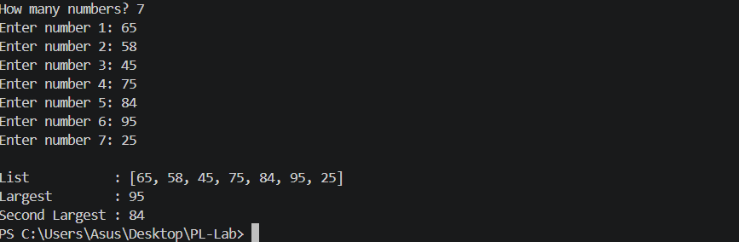
10.Write a program to demonstrate list slicing
my_list = [10, 20, 30, 40, 50, 60, 70, 80, 90, 100]
print(f"Original list : {my_list}")
print(f"First 3 elements : {my_list[:3]}")
print(f"Last 3 elements : {my_list[-3:]}")
print(f"Elements from index 2 to 6 : {my_list[2:7]}")
print(f"Every 2nd element : {my_list[::2]}")
print(f"Reversed list : {my_list[::-1]}")
print(f"Middle elements (3-7) : {my_list[3:7]}")
Output:
